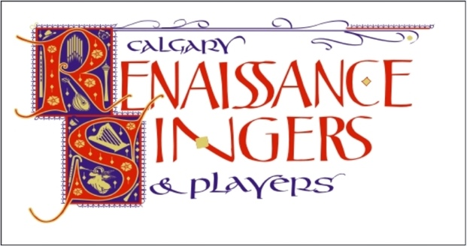

CALGARY RENAISSANCE SINGERS & PLAYERS

BOARD CONTACT INFORMATION

Position | First Name | Last Name | email | Phone
Artistic Director | Jane | Perry | piano_fingerings@hotmail.com | 587.351.8357
President  Vice President | Marsha  Frejya | Haug  Evenstar | marshajhaug@gmail.com  frejya3@gmail.com | 403.437.1796  403.270.0843
Secretary | Lisa | Hurrle | lisaphurrle@gmail.com | 403.305.5227
Treasurer  Director | Michael  Marcia | Bruch  Epstein | mjbruch@telus.net  marcia.epstein@shaw.ca | 403.246.0925  403.891.0743
Director  Director  Non-voting  Non-voting | Jennifer  Ian  Jennifer  Elizabeth | Hibbard  Kennedy  Farrand  Graves | jhibbard@shaw.ca  sam.ian@telus.net  j_farrand@hotmail.com  elizabethgraves4@gmail.com | 403.547.1544  403.826.0320  403.614.8563  403.975.9127

